Getting started

Documentation for the Tom.bio ID Visualisation Framework



Dr Richard Burkmar

Biodiversity Project Officer

Field Studies Council

Head Office

Montford Bridge

Shrewsbury

SY4 1HW

richardb@field-studies-council.org

Tel: (01743) 852125

Tomorrow's Biodiversity Project funded by the Esmée Fairbairn Foundation

# Contents

1 Contents 2

2 Introduction 3

3 Installing the Tom.bio ID Visualisation Framework 3

4 Set up your computer to run web pages locally 4

5 Run the visualisation web page 4

6 Create a new knowledge-base and visualisation 5

# Introduction

The FSC Tom.bio ID Visualisation Framework is an open source framework for creating new identification resources that run as ‘web apps’ in web browsers. You can use the framework to create a new ID web app simply by creating a knowledge-base using a spreadsheet.

But it’s not always convenient or desirable to run your app on a website, especially while you are developing a new knowledge-base. The good news is that you don’t have to. Instead, you can get your own computer to run as a little mini-webserver and run it locally.

These instructions tell you:

1. How to install the framework on your computer.
2. How to set up your computer to run web apps locally.
3. How to run the visualisations web page.
4. How to start a new knowledge-base and web app of your own.

# Installing the Tom.bio ID Visualisation Framework

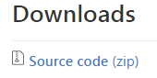These are the steps for installing the framework on your computer.

1. **Download the latest version of the framework** from <https://github.com/burkmarr/tombiovis/releases> - download the latest ‘**Source code (zip)**’ file.
2. Unzip the framework zip file to a convenient location on your computer.

The framework is delivered as a zip file. Once you’ve downloaded and unzipped this file you will find a folder called something like: **tombiovis-1.2.3** (the version number at the end might be different). If you have a look in this folder you will see the folders and files shown below.

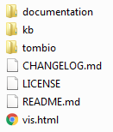

# Set up your computer to run web pages locally

There are many ways you could set up your computer to run a local web server[1]. Early versions of the framework suggested using a program called ‘Node.js’ to do this, but we now recommend a much simpler cross-platform way of doing it with Google Chrome.

The ‘Web Server’ add-in is a simple tried, tested and trusted add-in to Google Chrome. It is simple to install and run on any platform that is supported by Chrome (including Windows, Mac and Linux).

1. If you don’t already have Google Chrome installed on your computer, do that first.
2. From the ‘Chrome Web Store’ (<https://chrome.google.com/webstore/category/extensions>) search for and then add the ‘Web Server’ app to Chrome.

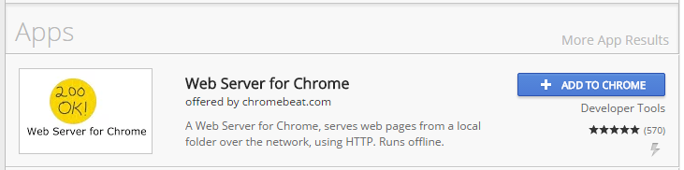

Note that resources created with the Tom.bio ID Framework can be viewed on any modern browser, not just Chrome, so users of your visualisations have a free hand when it comes to browser choice. But as a knowledge-base developer, Chrome provides the best environment for you to work in.

# Run the visualisation web page

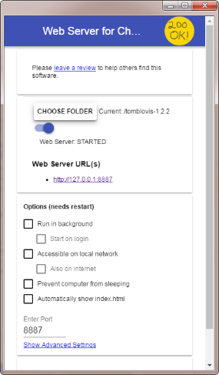These steps show you how to run the visualisation app on your computer.

1. From Chrome, start the Web Server add-in and use the *Choose folder* button to select your framework folder (e.g. tombiovis-1.2.3).
2. Start the framework by entering the following URL into your web browser: <http://127.0.0.1:8887/vis.html>

Step 1 starts the local web server. To start a Chrome add-in, click the *Apps* icon shown on the left which will show a tab in Google Chrome with your installed extensions. Then click the image corresponding to the Web Server add-in (also shown on the left). You can minimise the web server window whilst working with the framework. When you close the web server window, it will stop running.

Step 2 starts the visualisation web app. It is running on the example knowledge-base provided with the framework – the biscuits knowledge-base.

Repeat these steps whenever you need to start the local web server and the visualisation app.

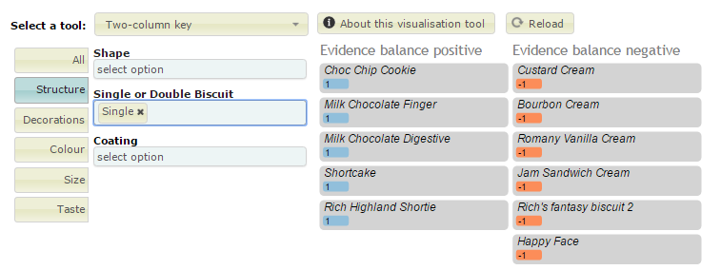

# Create a new knowledge-base and visualisation

It is unlikely that you downloaded the framework to obtain an idenfication resource for biscuits! Its more likely that you want to have a go at creating a new knowledge-base of your own to drive a new ID resource. Here’s one way you can make a start.

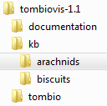(You are given only the very briefest introduction to creating a knowledge-base below. For a proper guide you should read the ‘Building a knowledge-base’ document included with the framework.)

1. In the ‘kb’ folder in the main framework folder, **create a new folder** corresponding to the resource you’d like to make, e.g. ‘arachnids’.
2. **Copy** the file ‘**kb/biscuits/biscuits.xlsm**’ into your new folder and rename it, e.g. ‘**kb/arachnids/arachnids.xlsm**’.
3. In the main framework folder, you will notice a file called ‘**vis.html**’ – this is the main web app page. (It’s a very lightweight little thing – the framework loads your visualisation into this dynamically.) **Open this file in a text editor**. In some text editors, it appears nicely formatted as show below.

<!DOCTYPE html>

<html lang="en">

<head>

<meta charset="utf-8">

<title>Tom.bio ID Visualisation</title>

<!--Change the tombiopath variable to match the installation environment-->

<script>var tombiopath = "tombio/"</script>

<!--Change the tombiokbpath variable to pick up the KB you are working with-->

<script>var tombiokbpath = "kb/biscuits/"</script>

<!--Change the path to load.js to match the installation environment-->

<script type="text/javascript" src="tombio/load.js"></script>

</head>

<body leftmargin="100px">

<h1>Tom.bio ID Visualisation test page</h1>

<div id="tombiod3"></div>

<h1 style="width: 100%">footers</h1>

</body>

</html>

In other text editors, e.g. Notepad, it may look rather more like this:

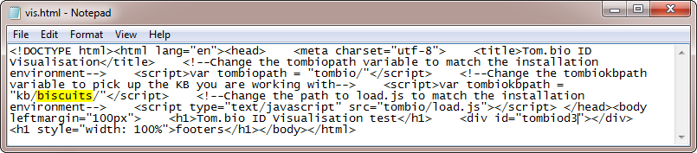

1. You need to direct the app page to look for your new knowledge-base rather than the biscuits one. To do that, **change the path of the knowledge base folder to the folder you just created** by changing the word ‘biscuits’ to the name of your new folder (e.g. ‘arachnids’) – see text highlighted in yellow above.

|  |  |  |  |
| --- | --- | --- | --- |
| title | metadata | yes | Family Circle Biscuits |
| year | metadata | yes | 2016 |
| authors | metadata | yes | Bell, C. |
| publisher | metadata | no | Field Studies Council |
| location | metadata | no | Preston Montford, Shrewsbury |

1. **Save the changes** you made to ‘vis.html’.
2. Open your new knowledge-base Excel file (e.g. arachnids.xlsm) for editing. (You need to ensure that macros are ‘enabled’ – so respond accordingly to any questions.) On the ‘config’ worksheet, **change the values** of the **title**, **year**, **authors**, **publisher** and **location** keys. (You can leave the values of publisher and location blank if you like.) Also **delete** one of the **release history** lines and edit the remaining one to something suitable.
3. Go to the ‘macros’ worksheet and **click the ‘Save worksheets as CSV’ button**. This creates five CSV files in the same folder as your knowledge base with the names, taxa.csv, characters.csv, values.csv, media.csv and config.csv, corresponding to the five worksheets of the same name in the knowledge-base. The framework reads these CSV files – not the spreadsheet – so you must repeat this step every time you modify the knowledge-base.



1. At this point you should be able to **run the web app** (see ‘Run the visualisation web page’ above) or, if it is already running, just **click the ‘Reload’ button**, to pick up the new knowledge base.

Currently it will look just like the biscuits knowledge-base because you haven’t changed anything except some of the configuration metadata. To confirm that you are picking up your new knowledge-base, select the ‘About the knowledge-base’ option from the ‘Select a tool’ drop-down. You should see some information reflecting the changes you made on the config worksheet.

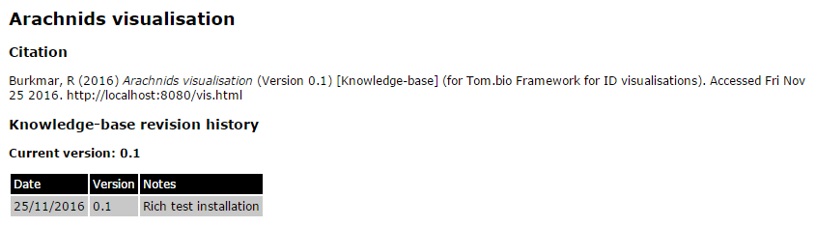

*At this point you’ve create a new knowledge-base and you understand how to run a visualisation from it on your computer and make changes. All that’s left to do now is populate the knowledge base with real information! For instruction on that, read the ‘****Building a knowledge-base****’ document.*

1. Note that running a local web server on your computer is not a security risk! It does not make your computer accessible to the outside world over the internet. It simply enables you to run a web application from your own computer, rather than over the internet.